**Screenshots:**

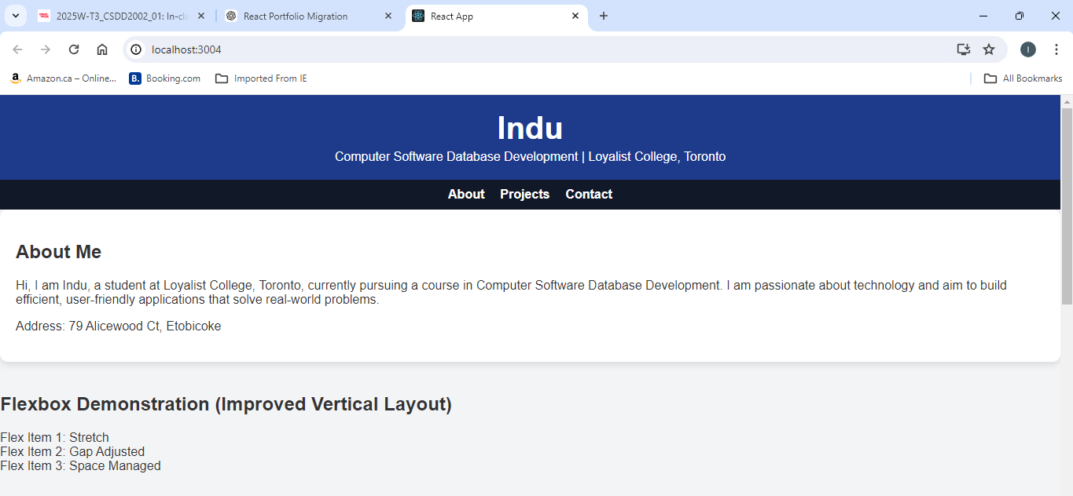

**React Code**:

**FlexboxDemo.js:**

import React from "react";

const FlexboxDemo = () => {

  return (

    <section className="flex-demo my-6 p-6 max-w-5xl mx-auto bg-gray-100 shadow-lg rounded-md">

      <h2 className="text-2xl font-bold text-orange-500 text-center mb-4">

        Flexbox Demonstration (Improved Vertical Layout)

      </h2>

      <div className="flex flex-col gap-6 bg-blue-100 p-6 rounded-md">

        <div className="bg-brown-500 text-white p-4 text-center rounded-md">

          Flex Item 1: Stretch

        </div>

        <div className="bg-brown-500 text-white p-4 text-center rounded-md">

          Flex Item 2: Gap Adjusted

        </div>

        <div className="bg-brown-500 text-white p-4 text-center rounded-md">

          Flex Item 3: Space Managed

        </div>

      </div>

    </section>

  );

};

export default FlexboxDemo;

**GridDemo.js:**

import React from "react";

const GridDemo = () => {

  return (

    <section className="grid-demo my-6 p-6 max-w-5xl mx-auto bg-gray-100 shadow-lg rounded-md">

      <h2 className="text-2xl font-bold text-purple-700 text-center mb-4">

        Grid Demonstration (Improved Layout)

      </h2>

      <div className="grid grid-cols-1 sm:grid-cols-3 gap-4 bg-purple-100 p-6 rounded-md">

        <div className="bg-purple-600 text-white p-4 text-center rounded-md">Grid 1</div>

        <div className="bg-purple-600 text-white p-4 text-center rounded-md">Grid 2</div>

        <div className="bg-purple-600 text-white p-4 text-center rounded-md">Grid 3</div>

        <div className="bg-purple-600 text-white p-4 text-center rounded-md">Grid 4</div>

        <div className="bg-purple-600 text-white p-4 text-center rounded-md">Grid 5</div>

        <div className="bg-purple-600 text-white p-4 text-center rounded-md">Grid 6</div>

      </div>

    </section>

  );

};

export default GridDemo;

**ProjectsSection.js:**

import React from "react";

const ProjectsSection = () => {

  return (

    <section id="projects" className="projects p-6 max-w-5xl mx-auto bg-white shadow-lg rounded-md my-6">

      <h2 className="text-2xl font-bold mb-4">Projects</h2>

      <div className="grid grid-cols-1 sm:grid-cols-2 gap-6">

        <div className="bg-green-100 p-4 rounded-md shadow">

          <h3 className="font-semibold">Project 1: E-commerce Website</h3>

          <ul className="list-disc pl-4">

            <li>Designed a user-friendly, responsive layout to ensure seamless shopping experiences across all devices.</li>

            <li>Focused on clean navigation and intuitive UI to highlight products and simplify the purchasing process.</li>

            <li>Integrated modern design trends with branding elements to enhance the website's visual appeal and user engagement.</li>

          </ul>

        </div>

        <div className="bg-green-100 p-4 rounded-md shadow">

          <h3 className="font-semibold">Project 2: Student Management System</h3>

          <ul className="list-disc pl-4">

            <li>Created an intuitive and responsive interface for managing student data, ensuring accessibility across devices.</li>

            <li>Designed dashboards and navigation layouts to simplify data entry, tracking, and reporting for users.</li>

            <li>Incorporated visual elements and typography to enhance usability while maintaining a professional and clean design.</li>

          </ul>

        </div>

      </div>

    </section>

  );

};

export default ProjectsSection;

**ContactSection.js:**

import React from "react";

const ContactSection = () => {

  return (

    <section id="contact" className="contact p-6 max-w-3xl mx-auto bg-white shadow-lg rounded-md my-6">

      <h2 className="text-2xl font-bold mb-4">Contact Me</h2>

      <p>Email: <a href="mailto:indunov20@gmail.com" className="text-blue-700 underline">indunov20@gmail.com</a></p>

      <p>Instagram: <a href="https://instagram.com/indu_in_tech" className="text-blue-700 underline">@indu_in_tech</a></p>

      <p>Phone: +1 647 123 4567</p>

    </section>

  );

};

export default ContactSection;

**AboutSection.js:**

import React from "react";

const AboutSection = () => {

  return (

    <section id="about" className="about p-6 max-w-3xl mx-auto bg-white shadow-lg rounded-md my-6">

      <h2 className="text-2xl font-bold mb-4">About Me</h2>

      <p className="mb-4">

        Hi, I am Indu, a student at Loyalist College, Toronto, currently

        pursuing a course in Computer Software Database Development. I am

        passionate about technology and aim to build efficient, user-friendly

        applications that solve real-world problems.

      </p>

      <p>Address: 79 Alicewood Ct, Etobicoke</p>

    </section>

  );

};

export default AboutSection

**App.js:**

import React from "react";

import "./App.css";

import AboutSection from "./components/AboutSection";

import FlexboxDemo from "./components/FlexboxDemo";

import GridDemo from "./components/GridDemo";

import ProjectsSection from "./components/ProjectsSection";

import ContactSection from "./components/ContactSection";

const App = () => {

  return (

    <div className="font-sans bg-gray-100 text-gray-700">

      <header className="bg-blue-700 text-white p-6 text-center">

        <h1 className="text-3xl font-bold">Indu</h1>

        <p>Computer Software Database Development | Loyalist College, Toronto</p>

      </header>

      <nav className="bg-gray-800 p-4 flex justify-center gap-6">

        <a href="#about" className="text-white font-semibold hover:underline">About</a>

        <a href="#projects" className="text-white font-semibold hover:underline">Projects</a>

        <a href="#contact" className="text-white font-semibold hover:underline">Contact</a>

      </nav>

      <AboutSection />

      <FlexboxDemo />

      <GridDemo />

      <ProjectsSection />

      <ContactSection />

      <footer className="bg-blue-700 text-white text-center p-4">

        <p>&copy; 2025 Indu. All Rights Reserved.</p>

      </footer>

    </div>

  );

};

export default App;

**App.css:**

body {

  font-family: Arial, sans-serif;

  margin: 0;

  padding: 0;

  background-color: #f3f4f6;

  color: #333;

}

header {

  background-color: #1e3a8a;

  color: white;

  text-align: center;

  padding: 20px;

}

header h1 {

  margin: 0;

  font-size: 2.5rem;

}

header p {

  margin: 5px 0 0;

}

nav {

  background-color: #111827;

  display: flex;

  justify-content: center;

  gap: 20px;

  padding: 10px;

}

nav a {

  color: white;

  text-decoration: none;

  font-weight: bold;

}

nav a:hover {

  text-decoration: underline;

}

main {

  padding: 20px;

}

/* About Section */

.about {

  margin-bottom: 40px;

  background-color: white;

  border-radius: 10px;

  padding: 20px;

  box-shadow: 0 4px 8px rgba(0, 0, 0, 0.1);

}

/* Flexbox Section */

.flex-demo {

  margin-bottom: 40px;

}

.flex-container {

  display: flex;

  flex-direction: column;

  gap: 20px;

  background-color: #bfdbfe;

  padding: 20px;

  border-radius: 10px;

}

.flex-container .bg-brown-500 {

  background-color: #5a463f;

  color: white;

  padding: 20px;

  border-radius: 10px;

  text-align: center;

}

/* Grid Section */

.grid-demo {

  margin-bottom: 40px;

}

.grid-container {

  display: grid;

  grid-template-columns: repeat(auto-fit, minmax(120px, 1fr));

  gap: 20px;

  background-color: #e9d8fd;

  padding: 20px;

  border-radius: 10px;

}

.grid-container .bg-purple-600 {

  background-color: #6b46c1;

  color: white;

  padding: 20px;

  border-radius: 10px;

  text-align: center;

}

/* Contact Section */

.contact {

  background-color: white;

  margin-top: 40px;

  border-radius: 10px;

  padding: 20px;

  box-shadow: 0 4px 8px rgba(0, 0, 0, 0.1);

  text-align: center;

}

.contact a {

  color: #2563eb;

  text-decoration: underline;

}

footer {

  background-color: #1e3a8a;

  color: white;

  text-align: center;

  padding: 20px;

  margin-top: 40px;

}